User Guide - Tool for FMS Data Analysis

Implementation and Requirements

*Roberto Briceno-Rosas¹, Joost Kappelhof², May Doušak³ and Paulette Flore²*

*¹* GESIS – Leibniz Institute for the Social Sciences

*²* SCP – The Netherlands Institute for Social Research

*³*University of Ljubljana

Requirements 1

Installation procedure 1

Downloading FMS Data 2

Implementation 2

Troubleshooting & FAQ 4

# Requirements

**Data requirements**

* *FMS Dataset*: Single country dataset downloaded from R11 version of the FMS for both app and upload portal in CSV format with comma as separator (standard download format). See section about downloading FMS data for details.

**System requirements**

* Windows 7 or newer
* .NET 4 or newer
* 2 GB free disk space

# Installation procedure

The tool resides in its folder and works without installation.

1. User should simply unzip the downloaded file anywhere on disk.
2. A new folder called “ToolFMSvx” will be created on destination (x for version of the tool).

Depending on the speed of computer, unzipping might take a few minutes.

# Downloading FMS Data

Please consult the FMS manual if you encounter any problems

1. Select the country
2. Download the data using the “export” function

# Implementation

Please note that **the logic of the implementation** is the same as in the Interim Dataset Analysis. Only the dataset used for the analysis has changed.

|  |  |
| --- | --- |
| a) Open the newly created folder “Tool” and run “Tool” file with the ESS logo (EXE file): | Graphical user interface  Description automatically generated with low confidence  aa  a |
| b) The application opens. The interface of the tool is shown on the right.  c) Please provide the *Main dataset* and the *Interviewer dataset* files, which should comply with the requirements previously mentioned. Both datasets need to be on the same file format (SAV, DTA, SAS, or CSV files)  d) Please choose output folder where the report PDF will be saved.  e) e) Select the correct script for analysing the selected datasets. For FMS Upload, select “Analysis FMS Upload R11”. For the FMS App, select “Analysis FMS App R11”.  f) Click “Generate”. The tool will indicate that is generating the report below.  *Depending on your computer, report generation might take anywhere from 5 to 30 minutes. In some cases, it might take up to an hour.*  g) Retrieve the PDF Report from the designated folder. Please take the time to review the report and discuss any issues with the survey agency and the CST. Share the report with your Country Contact.  h) Note that an annex folder will also be copied. It contains more detailed results for each indicator as CSV files to help investigate the issues. You can also find the csv files in the folder Tool_files\Annex within the tool. | Graphical user interface, text, application, email  Description automatically generated  f  d  c |
| a) Open the newly created folder “Tool” and run “Tool” file with the ESS logo (EXE file): |  |
| b) The application opens. The interface of the tool is shown on the right:  c) Please provide the ***FMS data***from app or upload portalon “choose file” buttons.  d) Using the button “choose”, please select output folder on your computer where the report PDF will be saved. Please make sure that folder path **does not** contain spaces in the name.  e) Select the **analysis script** for the “FMS App R11” or for the “FMS Upload Portal R11”, which determine with syntax will be used.  f) Click “**Generate**”. The tool will indicate that is generating the report below.  *Depending on your computer, report generation might take anywhere from 5 to 30 minutes. In some cases, it might take up to an hour.* | Graphical user interface, text, application, email  Description automatically generated  c  d |
| g) Retrieve the **PDF Report** from the designated folder. Please take the time to review the report and discuss any issues with the survey agency and the CST. Share the report with your Country Contact.  h) The annex folder within the tool will contain CSV files with the indicators from the report for more details. Go to “**Tool_files\Annex**” within folder of the tool. Country and FMS version will be shown in the file names. | Graphical user interface, text  Description automatically generated with medium confidence  h |
|  |

# Troubleshooting & FAQ

**Windows Smart Screen when first running the tool**

First time you run it, Windows Smart Screen protection might pop up: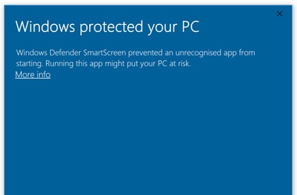Should this happen, please click “More Info” and press the button “Run Anyway”:

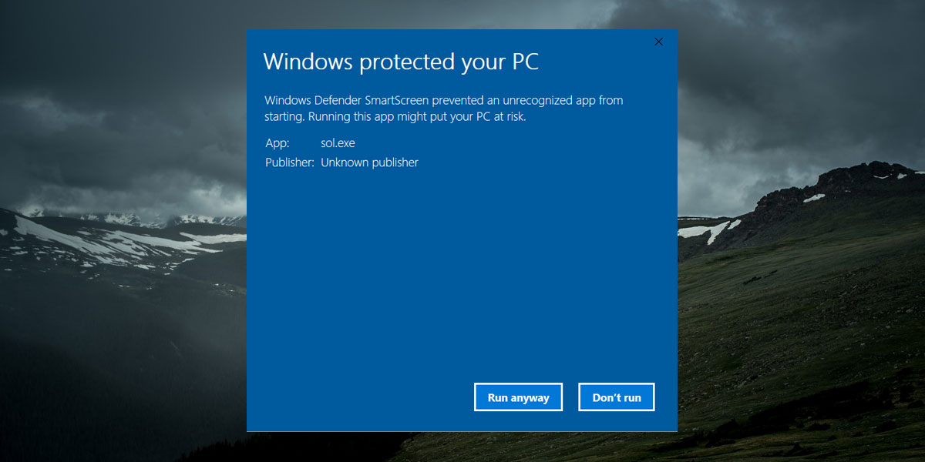

**Running the Tool in another operating systems like MacOS and Linux**

Currently, the CST only provide support for running the tool in Windows. However, it is possible to run the code and produce the PDF in MacOS and Linux. Some basic knowledge in R is required. For this purpose, users can extract the syntax (RMD code) and related files in order to run the code in their computers using R. Please note that users will need to install the necessary software (R, R Studio, and MikTex) and assigned the respective path for the datasets manually.